## **1. Notes (Group)**

Look at all of the artifacts and documents that have been created so far. What is the goal of the app? What are the features of the app?

Goal: Provide users with an easily used interface to evaluate and compare child mortality and aid data over time for various countries.

Features:

* Search bar
* Bar graphs
* Line graphs
* Pie charts
* Future predictions
* Navigation bar
* Word map, color coded
* Sortable list of countries with top level data in individual columns

## **2. Ideas (Group)**

Identify top non-intuitive features from feature list and assign each to at least two members. An intuitive interface would be a login interface. An example of a non-intuitive interface would be an interface that uses visualization to achieve a feature. E.g. in a car sharing app how would you visualize the available vehicles to users.

* A pie chart showing all major sources of aid across all countries to show which organizations have contributed the most, ex: (Jamie)

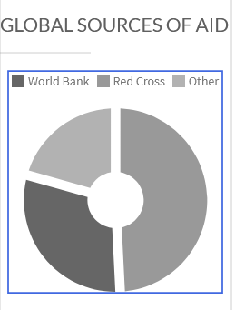

* A line graph showing how much aid a specific country has received over the years (Jamie)
* A bar graph comparing countries and the amount of aid they receive (Michael)
* Line graph showing future mortality predictions (Michael)
* Future aid predictions